**Brown Bear, Brown Bear   
What Do You See?**

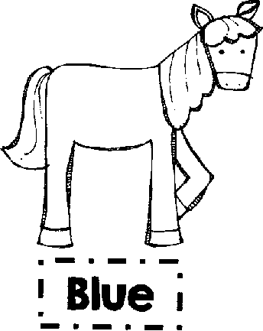

,a • SO

**! Blue**

**Ofl•**

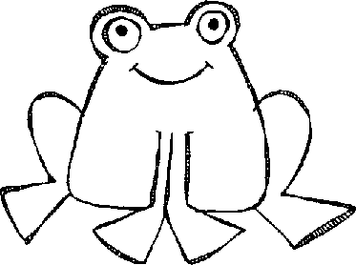

a

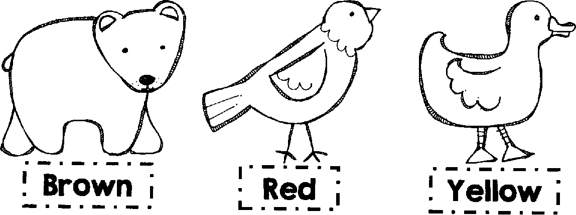

USW

**.1••••••**

**! Yellow ;**

**la • as a • as**

.

I

**OMIPMEMIOME**

**' Brown**

**SI. . RIM • NM . Me •**

* **i• -Red 1....**

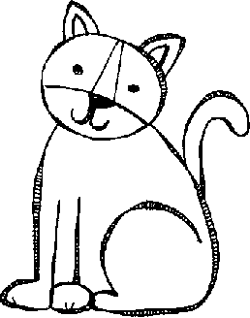

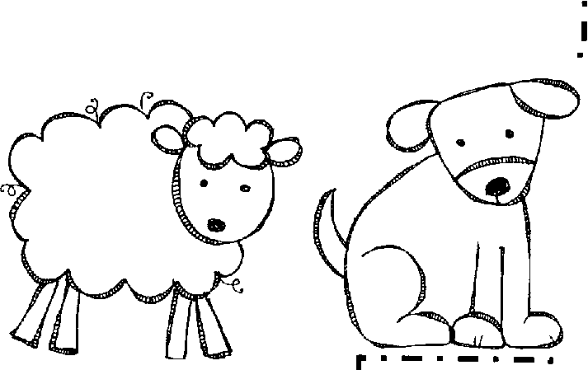**—**

**ME • •**

**' Green**

ananalla

* **—**
* **• •**

**1 Purple 1**

**1.. • a • sin • a •**

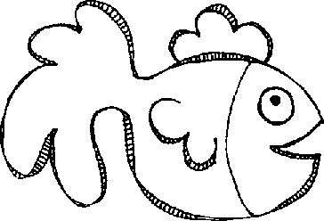

**.......**

**! Black "**

**; White 1**

**i...• alma..**

**'1•11812°1 •**

**1 Orange •**

**. - . J**

* **•M•**